# SQL TipsnHints - Restore Server Database Samples

You will need to download and restore the SQL Server Samples Databases used in the Demos, Labs and ICA solutions.

All SQL Server Database Samples are available from Blackboard: [Week 0: SQL Server Databases for Labs & Home](https://bb.tees.ac.uk/ultra/courses/_3447_1/outline/edit/document/_176261_1?courseId=_3447_1)

**Step 1:** Make a Directory [SSMS] and download the SQL Server **.bak** files from Blackboard - [Week 0: SQL Server Databases for Labs & Home](https://bb.tees.ac.uk/ultra/courses/_3447_1/outline/edit/document/_176261_1?courseId=_3447_1)

* TU Labs: **drive F or drive U**: on the **TU Labs**
* Home Setup: make a **SSMS** folder on your hardrive.

Make a folder on your User Drive are either U: or F: drive and copy over the .Zip files from Blackboard session.



Oct 2022 Samples SQL Server Samples which need Restoring on TU Labs and Home PCs.

* **Olympics.bak: 120 years of olympians, events and medals**
* **Movies.bak: worlds movie library database**
* **Video_Games: worlds video game library database.**
* **Superheros: Superhero database**
* **Universities: worlds Times ranked university** .

Oct 2022 Update: The following should be preinstalled in TU Labs.

* **TSQL.bak**
* **MusicMansh.bak**
* **FleetFactors.bak**
* **NHS.bak (SQL Server 2019)**
* **Library.bak**

**Step 2:** Run SQL Server or follow the instructions below if in the TU Labs.

In TU Labs run SQL Server or SSMS from [Appsanywhere](https://appsanywhere.tees.ac.uk/login)

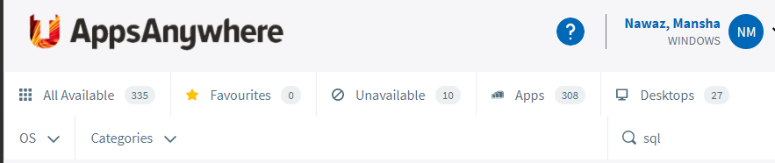

Launch the SQL Server Management Studio.

|  |  |
| --- | --- |
|  |  |

**Step 3:** To **Restore** the **.bak** files right click the Database for the Restore Database menu option as seen below:

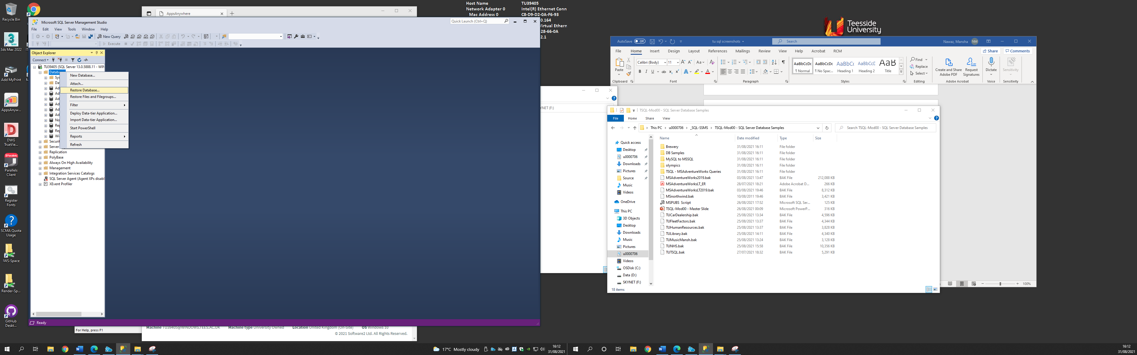

**Step 4:** Click on **Device** and expand the  **…** on the

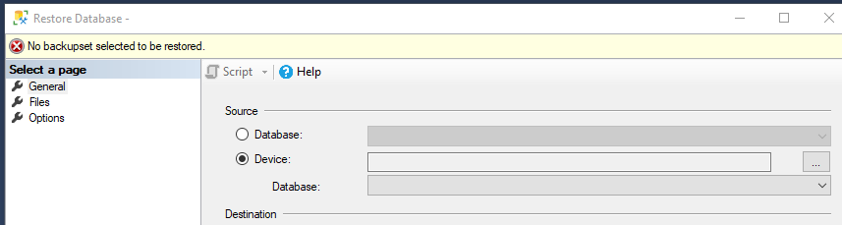

**Step 5:** Click **Add** and browse to where you have downloaded the **.bak** files to.

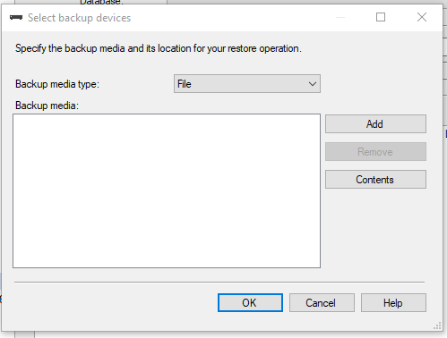

Note: Defaults **SSMS location** for **Backups** to **restore** from is:

C:\Program Files\Microsoft SQL Server\MSSQL13.MSSQLSERVER\MSSQL\Backup

However, the **.bak** files can be loaded from the hardrives folder you have downloaded to and do note SQL Server will not restore from USB or external drives.

Notice in the example below from **TU Labs** the **.baks** where downloaded to [**F: \TSQL-Mod00 – SQL Server DB]**

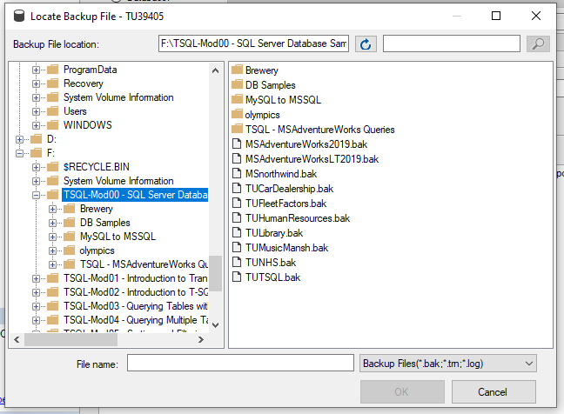

For the Demo I have selected tuTSQL (it may also be referred to as TSQL in all the Demo and Lab sessions).

**Step 5:** Click on **OK** and **SSMS** will have restored the **TSQL** Database used throughout most of the Demos.

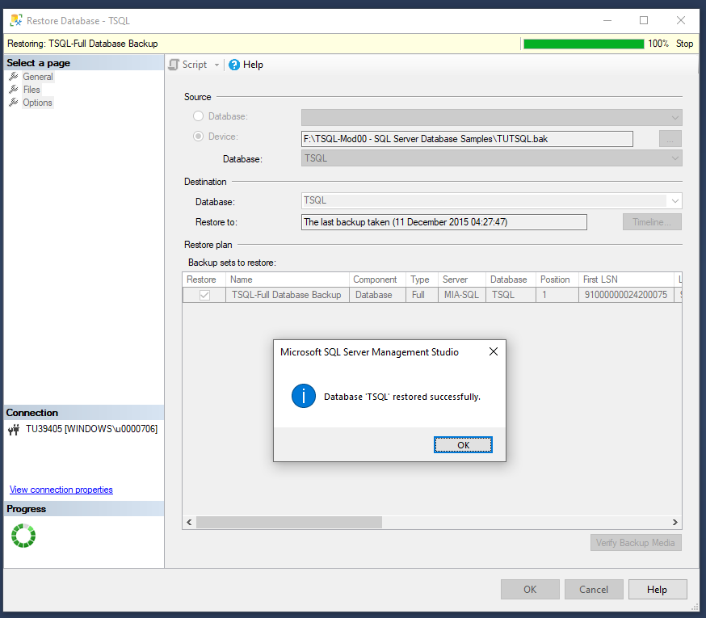

**Step 6:** Make sure the **.bak** is correctly load and the SQL Server Database is shown correctly in the Object Explorer as shown below:

|  |  |
| --- | --- |
|  |  |

Authorisation and Error 15517:

We can Backup and Restore SQL Server Databases – see SQL Server TipsnHints – Backup and Restore Databases.

However sometimes you will receive the following error as may not be authorised or have permissions to access the Database.

You will need to assign authorisation for your SQL Server account to access the Database(s) as follows:

Simply modify the below author authorisation by changing TSQL to the restored database name.

|  |
| --- |
| -- Microsoft SQL Server, Error:15174 when restoring .bak SQL DBs.  -- Login 'DomainName\abc'-- owns one or more database(s).  -- How to change the owner of da-- Change the owner of database(s)before dropping the login.  --To check the ownership of database "AdventureWorks2019"  SELECT name as [DB Name],  suser_sname(owner_sid) as [Owner]  FROM sys.databases  WHERE name='AdventureWorks2019'  --Change the ownership of database "AdventureWorks2019" to sa  ALTER AUTHORIZATION ON DATABASE::AdventureWorks2019 TO sa;  --Change the ownership of database "TSQL" to sa  ALTER AUTHORIZATION ON DATABASE::TSQL TO sa; |

Saving Changes not permitted Error:

By default SQL Server may also not permit you to make changes to the Database so you may also need to uncheck the Prevent making changes under Tools – Options as follows:

**SQL Server Error: Saving Changes is not permitted**

1. Open SQL Server Management Studio.
2. From the file menu, choose Tools à Options.
3. From the left menu, choose Designers.
4. Uncheck the box entitled Prevent saving changes that require table re-creation.
5. Press OK to save.

Uncheck – prevent saving changes

Demo and Lab TSQL Code

The Demo and Lab TSQL Code should work once you have downloaded the appropriate SQL Server Sample DB to work on. On home machines you may simply double click the **.sql demo** files.

Note in TU Labs you will have to open **.sql** files in **Notepad** and copy over the TSQL Code.

